Michael G. Inso Aptech-Qatar ACCP

SQL Server Management Studio is a software application first launched with Microsoft SQL Server 2005 that is used for configuring, managing, and administering all components within Microsoft SQL Server. It is the successor to the Enterprise Manager in SQL 2000 or before.

Database Design and Developement

Microsoft SQL Server Management Studio 2018



Statement and Confirmation of Own Work

|  |
| --- |
| ***A signed copy of this form must be submitted with every assignment.***  ***If the statement is missing your work may not be marked.*** |

Student Declaration

I confirm the following details:

|  |  |
| --- | --- |
| Candidate Name: | MICHAEL G. INSO |
| Candidate ID Number: | 00188933 |
| Qualification: | L5DC |
| Unit: | DATABASE DESIGN AND DEVELOPMENT |
| Centre: | APTECH QATAR |
| I have read and understood both NCC Education’s *Academic Misconduct Policy* and the *Referencing and Bibliographies* document. To the best of my knowledge my work has been accurately referenced and all sources cited correctly.  I confirm that this is my own work and that I have not colluded or plagiarised any part of it. | |
| Candidate Signature: |  |
| Date: | 4/14/2021 |

**OPS020_dec16_Candidate+Statement+of+Own+Work.doc**

**OPS020_dec16_Candidate+Statement+of+Own+Work.doc**

Table of Contents

**Table of Contents2**

**Figures and Table3**

**Acknowledgement4**

**Introduction5**

**Task 1: Description of Business 6**

1. Description of Business6
2. Entity Framework core NuGet7

**Task 2: ER and Data Dictionary8**

1. Jumplistic Interior Co Employees8
2. Jumplistic Interior Co Orders8
3. Jumplistic Interior Co Products9

**Task 3: Normalisation10**

1. Normalisation 10

**Task 4: Assessment of Design11**

1. Assessment of Design 11

**Task 5: Scripts to create table structures 12**

1. SQL server profiler 12
2. SQL Employee table 12
3. SQL Order and Orderline table 13
4. SQL Product and OrderStatus table 13

**Task 6: Data Population14**

1. SQL INDEX, REFERENCES, and CONSTRAINTS, etc.14

**Task 7: SQL reports15**

1. SQL Customer Data 15
2. SQL Employee Data 15
3. SQL Product Data 16
4. SQL Order Data 16
5. SQL Order Line Data 17
6. SQL Order Status Data 17

**Task 8: Future development of a distributed database18**

1. Future development of a distributed database 18-19

**Task 9: Evaluate the learning that you have undertaken in order to complete his assignment, using the Gibbs reflective cycle (1988) model 20**

1. Summary 20

References 20

Bibliography 20

Figures

Figure 1: **Example of Database Design**6

Figure 2: **NuGet Package** 7

Figure 3: **Example of SQL Database** 11

Figure 4: **SQL Server Profiler** 12

Figure 5: **SQL Employee Table** 12

Figure 6: **SQL Order Table and OrderLine Table** 13

Figure 7: **SQL Product and OrderStatusTable** 13

Figure 8: **SQL INDEX, REFERENCES, and CONSTRAINTS, etc.** 14

Figure 9: **SQL Customer Data** 15

Figure 10: **SQL Employee Data** 15

Figure 11: **SQL Product Data** 16

Figure 12: **SQL Order Data** 16

Figure 13: **SQL OrderLine Data** 17

Figure 13: **SQL OrderStatus Data** 17

Tables

Table 1: **Jumplistic Interior Co. Employees**8

Table 2: **Jumplistic Interior Co. Orders**9

Table 3: **Jumplistic Interior Co. Products**9-10

**Acknowledgement**

This solo project would not have been possible with a lot of dedicated special individuals putting their heart, trust and faith in me helping me to persevere and be persistent.

I would like to express my special thanks of gratitude to Aptech Qatar Education Centre who gave the amazing opportunity to do this strenuous project on the topic of Database Design and Development Microsoft SQL Server Management Studio 2018 for NCC-UK Diploma 5 Computing, which also helped me in doing a lot of exploration and investigation and I acquired so many new knowledge and skills about Microsoft SQL Server Management database design and development.

Secondly, I would like to thank professor Jaspal Singh and the faculties for their great assistance and would also like to thank my **family** who still give me sponsorship and accommodation they helped me a lot in completing this project within the limited duration of time. The year 2020 was a great distress to all of us because of the covid-19 pandemic. I hope 2021 would be a great year to all of us and all would go back to normal etc.

**Introduction**

I’m going to develop and design a database with the help of SQL (Structured Query Language) developed in the 1970s by IBM researchers **Raymond Boyce** and Donald **Chamberlin**. SQL is a domain-specific programming language used in coding and designing for managed data held in a relational database management system (RDMS), or for stream processing in a relational data stream management system (RDSMS). -Wikipedia

SQL (Structured Query Language) is used in managing and creating a database for your application, website, and network, etc. It is easy to learn and use.

In this project and assignment, I will be developing a technological futuristic furniture company that would have its employees, products, and orders, etc. be managed by Microsoft SQL Server.

**Task 1 – Description of Business**

The Jumplistic Interior Co. is an enterprise leading software company founded in Doha, Qatar. It focuses on building affordable furniture for consumers locally and internationally just like its competitors Ace, Zara, Ikea, and Midas. High-quality modern plants, toys, cabinets, sofas, tables, bed, showers, toilets, 8k television, furniture, etc. having it installed the latest and most advance technology from automated temperature control, sizable/adjustable, and A.I. controlled technology using Bixby or Siri.

Jumplistic Interior Co. has daily operations from:

Cashiers who transact take the customer purchased items and store them into database invoice & receipts.

Customer service & support help the customer choose an item and solve any product-related problems.

I.T. who manages our networks, websites, and technical difficulty or errors, etc...

Contractor’s professionals who provide skills or services to companies for a set time.

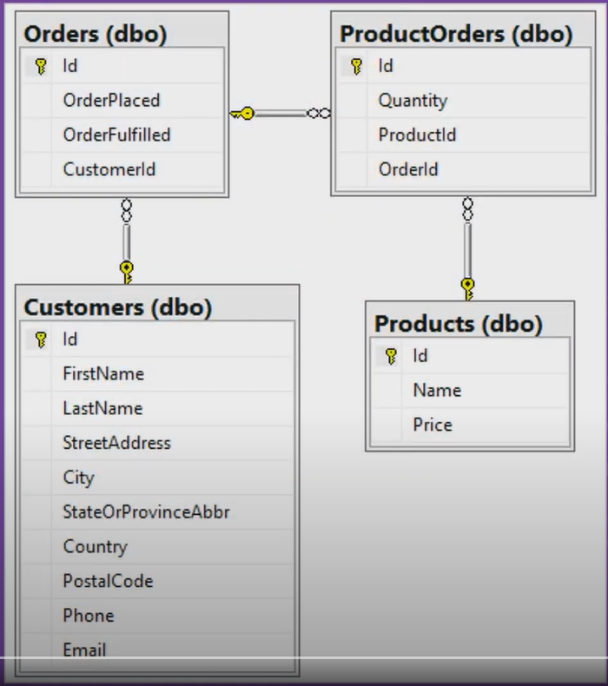Logistics detailed organization and implementation of our products, delivery, and storage, etc. Management of point of origins to the point of destination.

Database will collect Orders(dbo) (ID, OrderPlaced, OrderFulfilled, CustomerID), Product Orders (dbo), Customers(dbo), Products(dbo) (ID, name, and price), and also Employees (ID, first & last names, phone, email, address, and zip codes, etc.) departments, and contractors, etc.

**Figure 1: a.) Example of Database Design**

Our database would not include day-to-day simple transactions from order & product receipts, personnel delivery courier, company building electricity & water bills, and employees and customer food & drinks expenses, etc.

Below here as you can see the list of **NuGet Package** available for use in the Microsoft Visual Studio 2019 in Entity Framework Core:

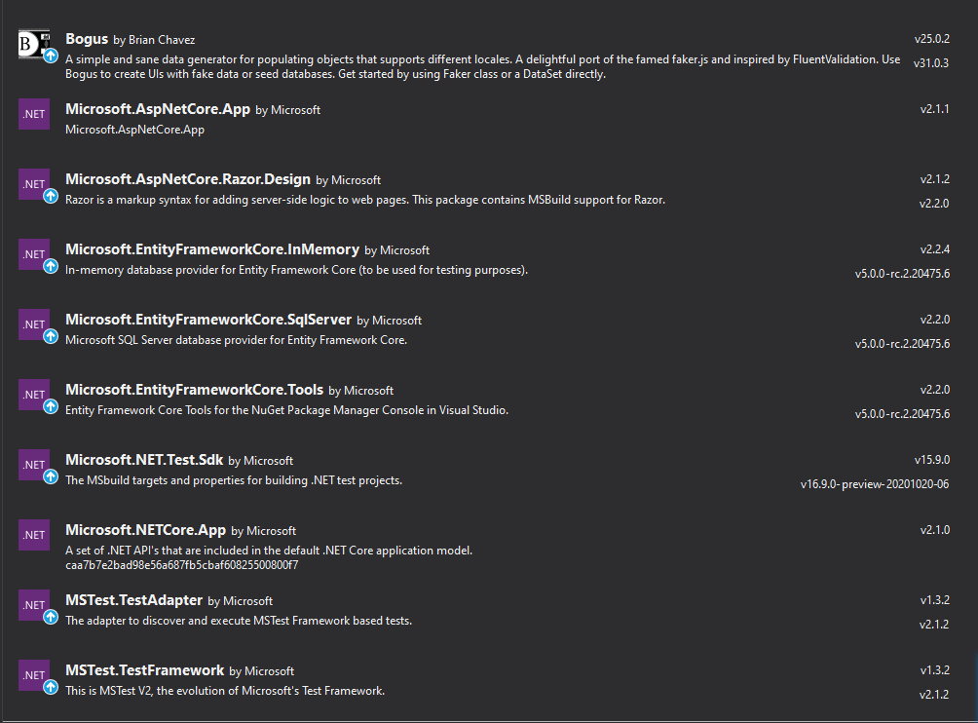

**Figure 2: b.) NuGet Package**

**Task 2: ER and Data Dictionary**

**Jumplistic Interior Co. _Employees**

|  |  |  |  |  |  |
| --- | --- | --- | --- | --- | --- |
| EMP_ID | EMP_NAME | EMP_ROLES | EMP_PHONE | EMP_EMAIL | EMP_ADDRESS |
| 567831 | Thomas Lyson | Software Engineer | +270-598-4702 | thomas_ly4@gmail.com | Toledo, Ohio, USA |
| 162789 | Doran Griffith | Sales & Cashier Rep. | +678-835-6708 | Doran_2griff@gmail.com | Clarkston, Georgia, USA |
| 756789 | Nigel Warner | Customer Service | +302-930-9058 | Ngel_war12@hotmail.com | Al Luqta, Doha, Qatar |
| 938761 | Tracy Barrett | Customer Support | +956-304-4121 | Tracy._.bar@yahoo.com | Madinat Khalifa, Doha Qatar |
| 456728 | Tony Dennis | Manager | +513-956-9985 | Tony45_dennis@yahoo.com | Indianapolis, Indiana, USA |
| 356721 | Joey Kennedy | Administrative Assistant | +781-733-9386 | Joey_ken49@hotmail.com | Spokane, Washington, USA |
| 256782 | Shannon Gibbs | System Engineer | +417-450-7201 | Shannon.123@hotmail.com | Laurel, Iowa, USA |
| 567821 | Ford Gildon | Human Resource | +609-453-2282 | Ford.Gildn12@gmail.com | San Diego, California, USA |
| 656789 | Baldwin Garner | Sales Representative | +218-598-5648 | Baln_Garner10@yahoo.com | West Bay, Doha, Qatar |
| 367823 | Zoe Moss | Software Developer | +918-991-2433 | Zoe0s12@gmail.com | New York, New York, USA |

**Jumplistic Interior Co. _Products**

|  |  |  |  |
| --- | --- | --- | --- |
| IIPRO_ID | PRO_NAME | PRO_PRICE | PRO_DATE & TIME |
| 100010 | Sofa v2 smoh | $80000 | 03/01/2021 07:27:40 |
| 110001 | Japan toilet auto201 | $70000 | 13/01/2021 08:55:34 |
| 010110 | Auto-heat Bed 24L | $25000 | 17/01/2021 20:25:04 |
| 001111 | A.I. C0ntrol Lampshade | $23000 | 20/01/2021 21:23:42 |
| 101010 | Audrino Plants v6 | $22000 | 12/02/2021 12:28:44 |
| 110111 | Cabinet v100 pq | $35000 | 01/03/2021 12:56:35 |
| 100001 | Television HD 12k | $1200000 | 05/03/2021 01:47:11 |
| 010101 | Rob0t Dog Pet v10 | $10000 | 23/03/2021 10:08:02 |
| 001001 | Robot Cat Pet v9 | $99000 | 24/03/2021 00:39:33 |
| 001100 | Auto-temp12 a.i. Shower | $50000 | 14/04/2021 06:48:54 |

**Jumplistic Interior Co. _Customer Orders**

|  |  |  |  |  |  |
| --- | --- | --- | --- | --- | --- |
| CUS_ID | CUS_NAME | CUS_ORDERS | CUS_PHONE | CUS_EMAIL | CUS_ADDRESS |
| 807337 | Jochim Graf | A.I. C0ntrol Lampshade | 678-617-2781 | Joch_graf@yahoo.com | 48 Lakeland Park Drive, Gainsville, Georgia |
| 833476 | Lene Schubert | Cabinet v100 pq | 619-894-8589 | Lene_Schu@gmail.com | 4744 Hamill Avenue, San Diego, California |
| 996681 | Mette Koch | Auto-temp12 a.i. Shower | 646-574-9185 | Mett_Koch@hotmail.com | 4945 Anmoore Road, New York, New York |
| 791854 | Karlotte Leitz | Sofa v2 smoh | 501-652-7601 | Karlotte_Leitz@yahoo.com | 1994 Masonic Hill Road, Morrilton, Arkansas |
| 699816 | Gitta Huber | Auto-heat Bed 24L | 510-389-2442 | Git_Huber@hotmail.com | 4630 Park Street, Oakland, California |
| 107465 | August Schulze | Rob0t Dog Pet v10 | 415-698-7667 | August_Schulze@gmail.com | 4121 Roosevelt Street, San Francisco, California |
| 460007 | Amalia Pohl | Robot Cat Pet v9 | 234-707-1858 | Amalia_Pohl@yahoo.com | 1746 Vineyard Drive, Euclid, Ohio |
| 025831 | Albrecht Mayer | Television HD 12k | 651-338-9577 | Alb_Mayer@hotmail.com | 3710 Post Avenue, Evansville, Minnesota |
| 450343 | Rikert Sachs | Japan toilet auto201 | 334-324-1591 | Rikert_sachs@gmail.com | 3989 Willow Greene Drive, Montgomery, Alabama |
| 029100 | Alina Feld | Audrino Plants v6 | 331-208-2412 | Alina_Feld@yahoo.com | 1074 Kembery Drive, Aurora, Illinois |

**Task 3: Normalisation**

Data normalisation aid us to diminish data duplication and assist in constructing a data structure. It helps us determine any error in the data provided by the user. Autocorrection is also provided by the excel spreadsheet software for any misspell or mistype of any data inputted by the user. 3NF normalisation can also help us determine the data from real versus data that isn’t provided by the company or user. The integrity of the data is the priority of 3NF normalisation. Normalisation would exceedingly help the user or the company organize and categorize its data.

The normalisation I created is organized in order of employee by employee_id, employee_name, employee_roles, employee_phone, employee_email, employee_address. Products are organized in order by product_id, product_name, product_price. The names and id are sorted out randomly. The chosen inputs are highly valuable employees and products of the company.

Data structures provided are arranged based on the input the user has given and can be easily reorganized alphabetically, numerically, and identically, etc. by the automated Microsoft excel spreadsheet software or any other software that is available for use. 3NF normalisation can be automated to ensure that any other aberration or other deviation would not cause any fib and disinformation or error in the inputted data.

**Task 4: Assessment of Design**

The database I created and constructed will be using SQL Server 2019 ([SQL2019-SSEI-Eval.exe](https://download.microsoft.com/download/4/8/6/486005eb-7aa8-4128-aac0-6569782b37b0/SQL2019-SSEI-Eval.exe)). The data and queries are categorized into three sections: Jumplistic Interior Co._Employees, Jumplistic Interior Co._Products, and Jumplistic Interior Co._Customer Orders. Each having its own distinctive and unrepeated data & query. They will be having NOT NULL and Unique to ensures that a column cannot have a Null value and each column are different. It can be shortened using the Primary key which is a combination of NOT NULL and Unique. The index will be added in the SQL so we can easily retrieve data from the database very quickly. Each has a FOREIGN KEY and CHECK that all values satisfy a specific condition. The data and query in each category are Jumplistic Interior Co._Employees (EMP_ID, EMP_NAME, EMP_ROLES, EMP_PHONE, EMP_EMAIL, and EMP_ADDRESS). Jumplistic Interior Co._Prodcuts (PRO_ID, PRO_NAME, PRO_PRICE, and PRO_DATE & TIME). Jumplistic Interior Co._Customer Orders(CUS_ID, CUS_NAME, CUS_ORDERS, CUS_PHONE, CUS_EMAIL, and CUS_ADDRESS). The primary key is a composite key for EMP_ID, PRO_ID, and CUS_ID they will use INTEGER. While EMP_NAME, EMP_ROLES, EMP_ADDRESS, EMP_EMAIL, PRO_NAME, CUS_NAME, CUS_ORDERS, CUS_EMAIL, and CUS_ADDRESS will use VARCHAR(20), VARCHAR(15), VARCHAR2(15), VARCHAR2(10), VARCHAR(255), and VARCHAR2(255). And EMP_PHONE, PRO_PRICE, and CUS_PHONE will be using DECIMAL(10,2) and DECIMAL(8,2). Also, PRO_DATE & TIME will be using DATE.

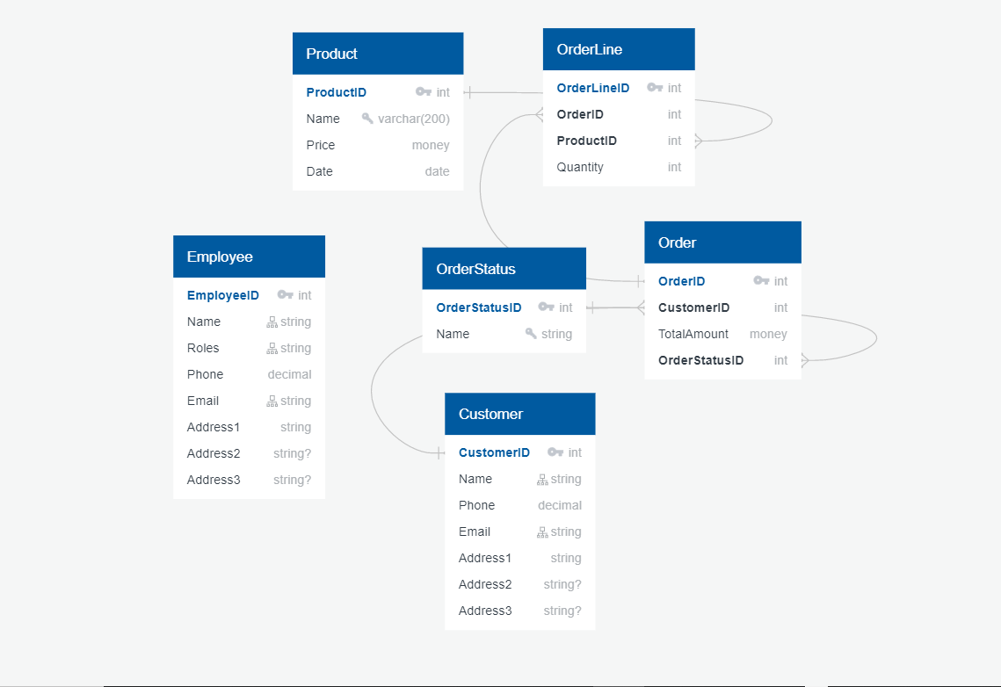

**Figure 3: a.) Example of SQL Database**

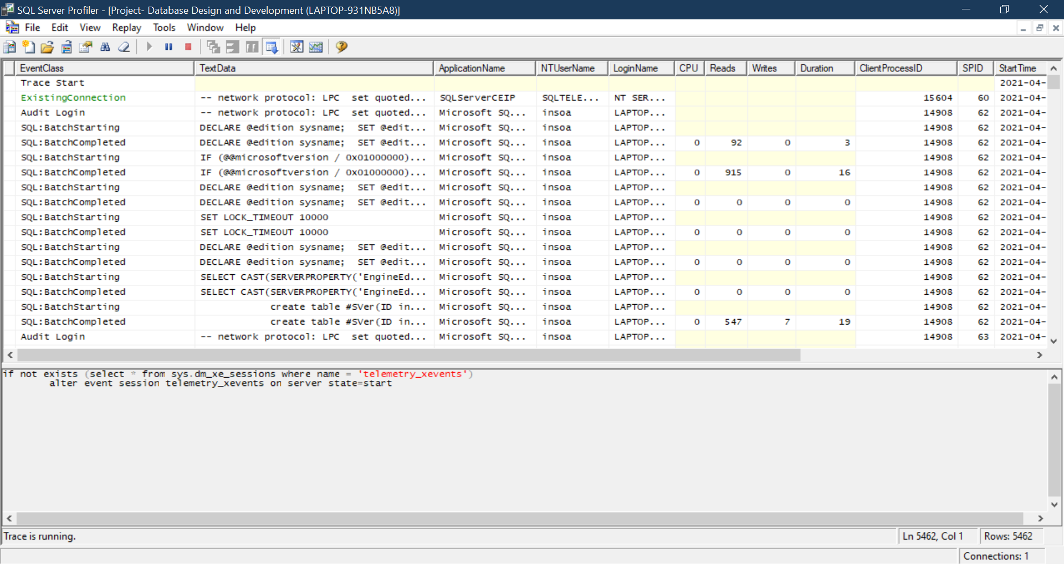**Task 5: Scripts to create table structures**

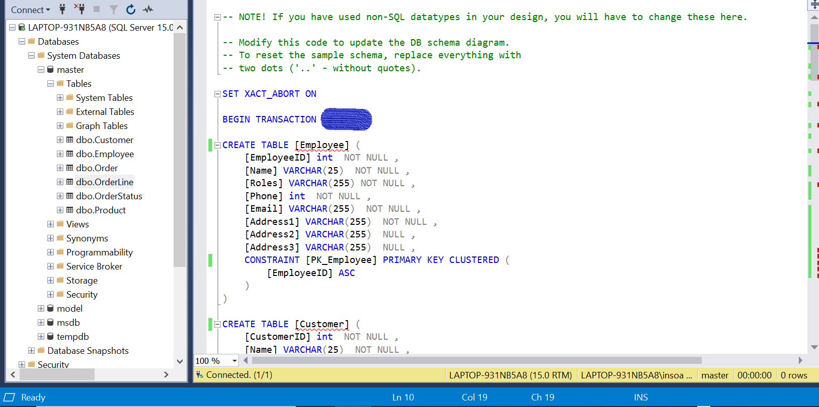**Figure 4: a.) SQL Server Profiler**

**Figure 5: a.) SQL Employee Table**

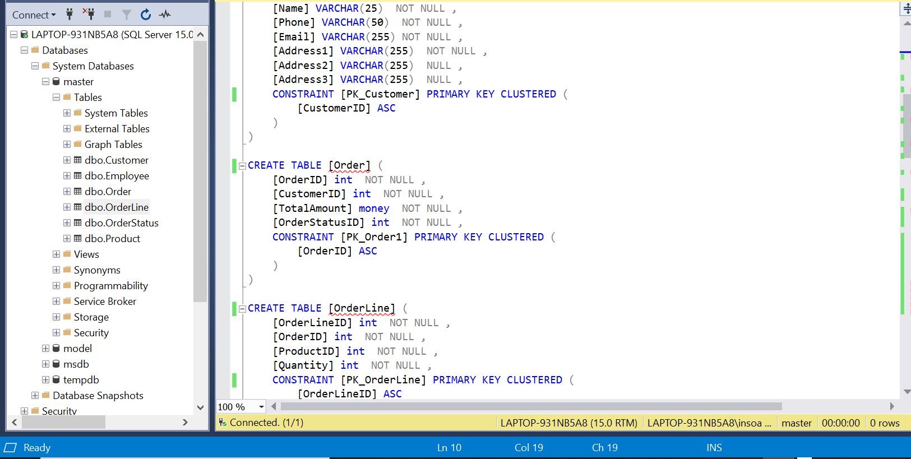**Figure 6: a.) SQL Order Table and OrderLine Table**

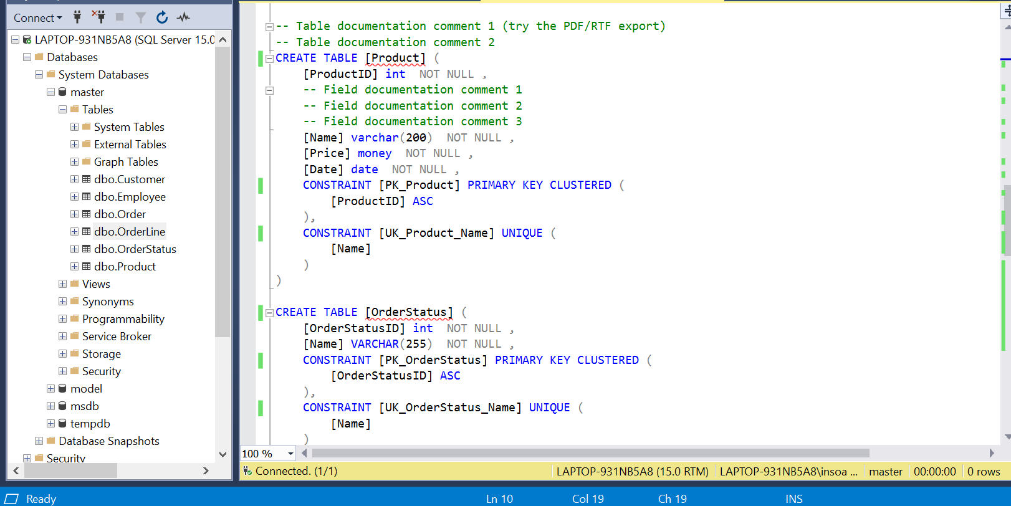

**Figure 7: a.) SQL Product and Order StatusTable**

SQL help my database categorized each of the data and value I have for my application or websites. It ensures that my inputted code has coherence and integrity. It eases the programmers like me to not worry about inaccuracy and error of the data I have provided.

The database SQL I created uses and has the availability of all integrity constraints from domain, entity, referential, and key. Unique constraints help me execute the process especially Primary Key and Foreign Key constraints prevent me from having duplicate and null values in my database. Also having NOT NULL in each of my columns prevent me from having NULL values.

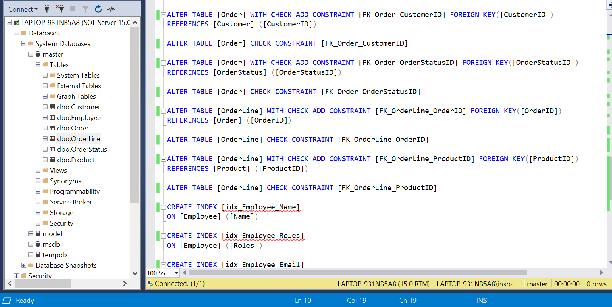**Task 6: Data Population**

**Figure 8: a.) SQL INDEX, REFERENCES, and CONSTRAINTS, etc.**

The SQL database I created have ALTER TABLE for each [tablename] and have WITH CHECK ADD CONSTRAINT for each [FK_columnsname_columnsname] and Foreign Key for [columnsname] References for each [columnsname] it is INDEX for each [columnsname]. ALTER TABLE [tablename] CHECK CONSTRAINT [FK_columnsname_columnsname]. CREATE INDEX [idx_tablename_columnname]

Most of the problems and errors are encountered are false negative axion of the code that I already have the given table and column name or either index exists in table etc. But mostly the SQL code works properly and displays accurate results.

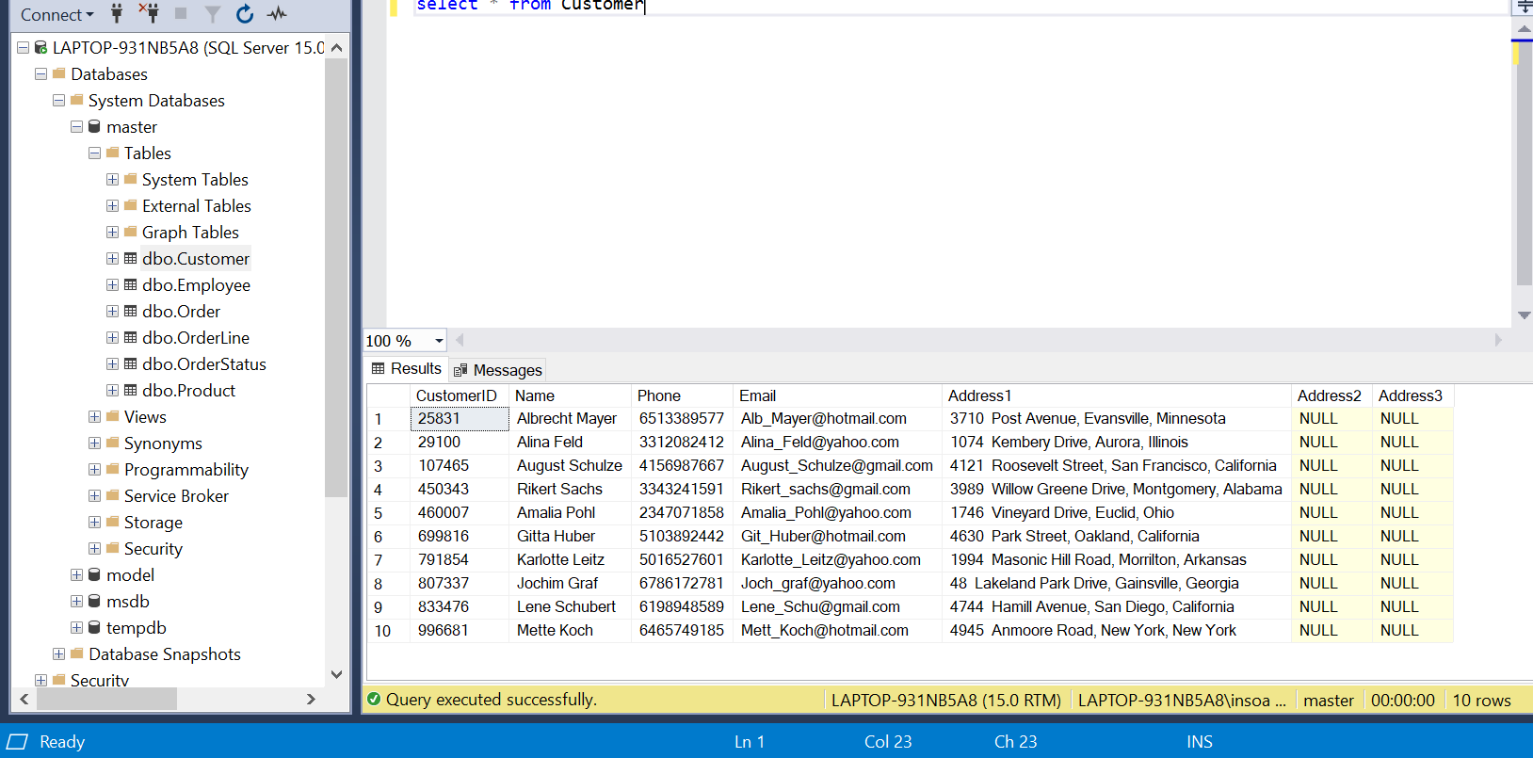**Task 7: Data Population**

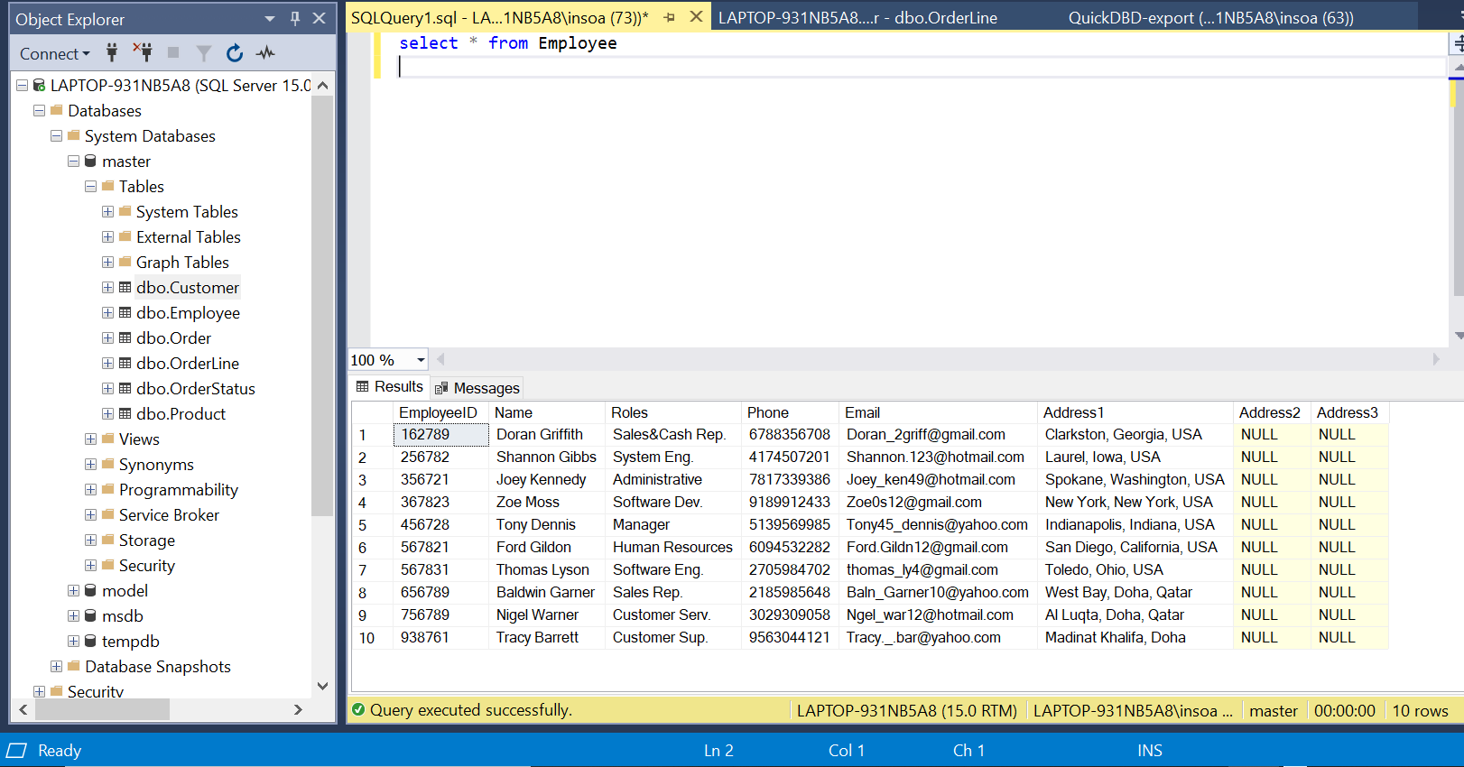**Figure 9: a.) SQL Customer Data**

**Figure 10: a.) SQL Employee Data**

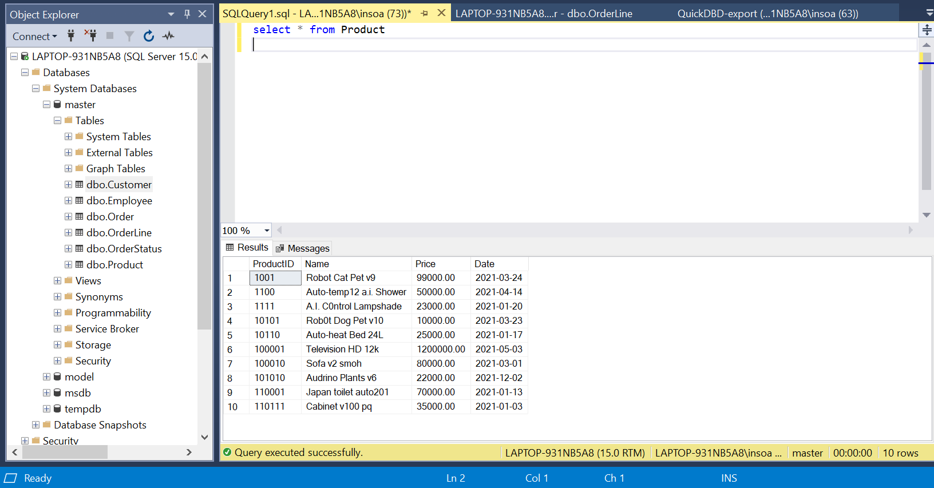**Figure 10: a.) SQL Product Data**

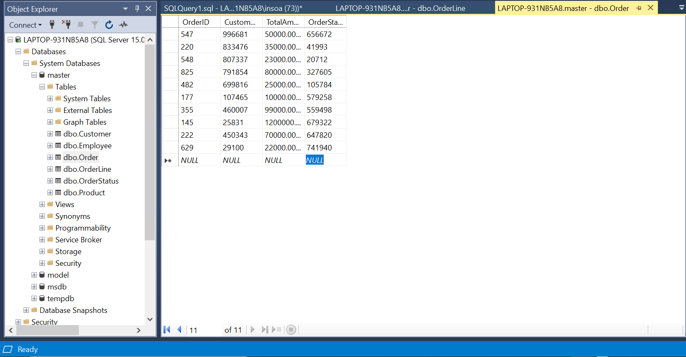

**Figure 11: a.) SQL Order Data**

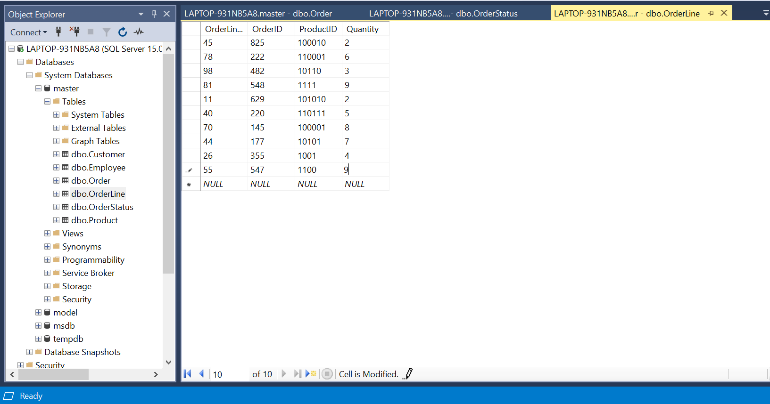**Figure 12: a.) SQL OrderLine Data**

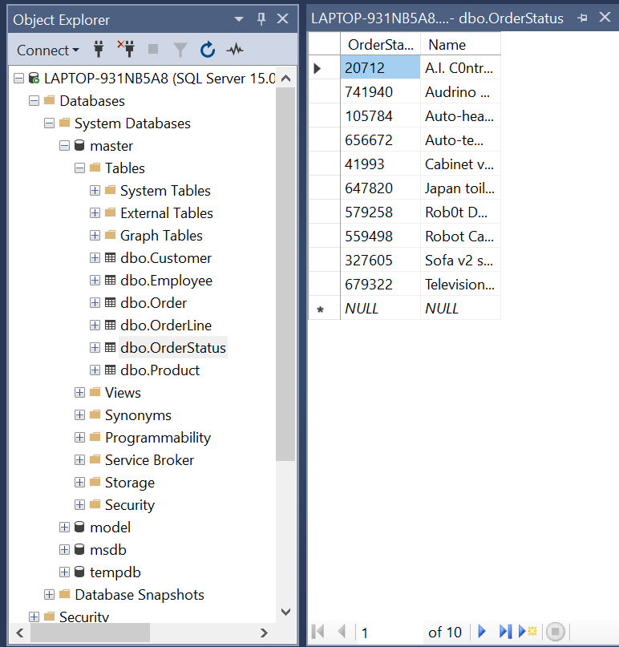

**Figure 13: a.) SQL OrderStatus Data**

My SQL database retrieves each of the Orders from the OrderID of the Customer CustromerID from their chosen high-tech quality Products with its finite quantity. And ensures that the order is delivered or not by having the Order Status table having it an organized delivery with OrderLine table. All of my tables are interconnected with each other. A very complex order, delivery, and customer, etc. database.

The database also has a list of employees with their (email, phone, & address, etc.), and customer (email, phone, & address, etc.), products date of purchase, and the total amount of purchase.

The SQL database I created to index the data for each table or column. It ensures that it has no duplication and replication for each data for it retrieves data in the database rapidly. Primary Keys ensures that most of my code & data doesn’t have similarity and has no empty values. Primary Key is a mix of NOT NULL and Unique. Foreign Key is available to all of my tables it helps my database identify each row/column in another table for duplication.

I used task 2 as my references for my Employee, Products, and Customer data. While in Order, OrderStatus, and OrderLine I have the help of a random number sequence generator. Even though the random number generator produces some duplication my Unique constraints ensure that it won’t.

All of my tables are interconnected with each other in a very complex way from Products into OrderLine having ProductID and OrderID into Order having it a CustomerID and OrderStatusID from OrderStatus and Customer.

**Task 8: Future Development of Distributed Database**

A distributed database system that has multiple files in a network or entirely different network. Imagine a database that is used by entirely different companies that is a distributed database. The database might be in the same location or dispersed over a network interconnected with multiple computers or like a cloud or VPN only the net.

Types of Distributed Database:

Homogeneous Database different sites cached of database interchangeably. They have the same technology, computers, and database applications. The operating system, database management software and data structures are similar and locations are also in the same area.

Heterogenous Database has different sites cached database with different operating system, database management software, data structures, and data models, etc. other companies may not be aware of each other and anonymized in the system. They have contrasting technology, computers, and database applications. Hence, they need different sites or locations for each other to communicate and interface.

A distributed data storage is categorized into:

Replication and Fragmentation (Horizontal fragmentation and Vertical fragmentation)

A company or an organization may consider using distributed database because of its reliability it has no drawbacks and risk of omission. If errors happen the entire distributed database is not affected.

The security of the distributed database has different levels of permissions of access depending on the user and employee. Lower-level employees or subordinates won’t have access to the higher level. Also, the different locale of the distributed database has a higher chance of internal and external protections.

It is cheap and cost-effective since remote access is uncommon and less frequent.

Growth and development add new business ventures, creating additional nodes with the database are effortless making it expandable.

Speed & resource efficiency distributed database access and activity is mostly in the local locale. Reducing remote access traffic.

Responsibility and containment trojans, viruses, glitches, and failures, etc. occur in the local server. The problem can be decoded, decipher, and solved by the IT and cyber-security staff of the company.

Jumplistic Interior Co. is using distributed database having different franchises and locations all over the world. The company uses vertically fragmented data enabling the access of the primary key available to each section or branch of the database. This type of distributed data storage is efficient for multi-tasking, examples are changing client location vs changing the stock portfolio of the company. It is also recommended for the company for its main location is in Doha, Qatar has access to the same account of the company. Distributed database exceptionally needed for the diversification and expansion of the company to different branches in different geographical locations.

**Task 9: Evaluate the learning that you have undertaken in**

**order to complete this assignment, using the Gibbs reflective**

**cycle (1988) model**

* This project is pretty straightforward the use of common programming languages like SQL for developing and designing a database is required. You can also use PostgreSQL or Apache alternatively. SQL (Structured Query Language) is pretty easy to grasp and utilize.
* Producing this project in Microsoft SQL Server I needed to download and use the latest Windows Microsoft Server 2019 [SQL2019-SSEI-Dev](https://download.microsoft.com/download/d/a/2/da259851-b941-459d-989c-54a18a5d44dd/SQL2019-SSEI-Dev.exe) made this project achievable and possible.
* Project examples like this with the use of the conceptual company you're required to code and process attributes like the entities, employees, contractors, customers, products, and departments, etc.
* Alternatives from this project can range from citizen data collection for utilizing it into national, tax, real estate, and vote, etc. Complex and intricate projects can involve the use of Artificial Intelligence, Deep Learning, and Machine Learning.
* This project is strenuous and difficult having a 1-month deadline also made it traumatic. Pandemic and quarantine also took a toll on my mental and emotional health. Also not being able to go back home-town and travel is frustrating, we all had the challenge of last year's covid-19 pandemic and it all took toll in our mental and emotional health changing our perception about public health and sanitation. I hope this year 2021-2022 would all go back to normal.

**References:**

**Bibliography**

<https://www.microsoft.com/en-us/sql-server/sql-server-downloads>

<https://docs.microsoft.com/en-us/sql/ssms/download-sql-server-management-studio-ssms?view=sql-server-ver15>

<https://www.atlantic.net/vps-hosting/about-distributed-databases-and-distributed-data-systems/>

Pages: 21

Words: 3,081

Characters (no spaces): 17,680

Characters (with spaces): 20,768

Paragraphs: 345

Lines: 706